Bowling alone in the AI era.
Chatbot sycophancy, hyper-personalised filter bubbles, and the breakdown of deliberation

Minahil Malik
Mikael Sundström

Abstract
This article examines large language model (LLM) sycophancy and its detrimental democratic-communicative fallout by means of an experimental study, and a bespoke extension of deliberative-democratic theory.

Machine learning techniques were employed to generate synthetic data in the form of tens of thousands of diverse political prompts. These were fed to the investigated LLMs to establish a control group of responses. The same queries were then accompanied by ideologically-aligned biographical information to establish treatment group responses. An ensuing probabilistic response comparison confirmed a substantial and statistically robust pattern of preference-aligned response shifting that even overwhelmed initial model bias headwinds where extant.

A theoretical lens based on deliberative-democratic theory, where communicative friction became a core investigative concern, was then developed and applied to human-LLM communication where such sycophancy is a prevalent factor. LLM sycophancy reduces communicative friction to the point where the apparently neutral artificial interlocutor is in fact reinforcing pre-existing notions, thus creating a hyper-personalised filter bubble that imperils productive democratic communication.

The identified dynamics are not a remote theoretical notion, but are already impacting live users. Moreover, the psychologically alluring conversational mode of human-LLM interaction, and the gradual accretion of LLM knowledge about prompters – both aspects underpinned by strong market incentives – make for a situation where the identified concerns are likely to grow steadily more serious unless intervention strategies.are developed.

Introduction
Warnings about dangers associated with artificial intelligence (AI) are far from uncommon, verging on à la mode. Identified issues range from truly existential global catastrophic risks (Turchin 2019: 46) if the development trajectory continues unimpeded, to immediate concerns such as increasingly challenging information assessment when tools allowing the production of convincing fake texts, images and videos become readily available; how AI models sometimes “hallucinate” and more.
Filter bubbles have long been discussed by social scientists and beyond (e.g., Barberá 2020; Ross Arguedas et al. 2022). One powerful element of the filter bubble dynamics is that the individual becomes situated in a community of like-minded people who will continually reinforce shared beliefs and belief-systems (Barberá 2020: 34) and that this will as a matter of course stifle open and honest debate, and constrict the exchange of ideas. Still, people are complex, and group consensus dissonances can and do appear in the most tight-knit of communities. But what if you had an artificial communication partner that was highly responsive to your apparent preferences, and often did so in fluent, confident language? If you explicitly or implicitly challenged anything the partner was stating, it might quickly yield or supply additional support for your viewpoint, not because the evidence requires that shift, but because the interactional design rewards helpful, agreeable response patterns. In short, they will take you seriously. But in so doing, they will also subdue or hide contradictory facts and viewpoints. Suddenly you have created a personalised filter bubble without the risk of the friction that is a challenging but in many ways valuable part of normal human interaction. Morton (2025) argues that LLMs function as communication partners with affective presence, meaning that any perceived disconnect between true interpersonal interlocution and human-machine communication can be reduced to the point where elicited emotional responses are not guarded by the logical realisation that the counterpart is not “real”. This increases the potency of the effects we are describing.
“Sycophancy” is a technical term in AI safety and alignment research (e.g., Park et al. 2024; Sharma et al. 2024, where it represents an LLM’s tendency to respond to a question with a user’s preferred answer to look favourable even if that answer is not objectively correct, often sacrificing accuracy and impartiality (e.g., adapting conservative views once a user reveals a conservative bent) (Wei et al. 2023: 1-3; Guo 2024: 7). Systematic study of sycophancy in the humanities and social sciences, including its broader implications for democratic deliberation, remains underexplored, however.
This behaviour is often attributed to reinforcement learning from human feedback (RLHF), through which human preferences may reward responses that align with user beliefs rather than truthfulness (Sharma et al. 2024). However, recent technical work suggests that sycophancy is not reducible to RLHF alone. It likely emerges from interacting sources, including agreeable patterns in pre-training data; instruction-tuning objectives that prioritise smooth helpfulness and user satisfaction; reward models that conflate helpfulness with agreement; tensions between helpfulness, harmlessness, and honesty; and interface-level pressures toward affectively comfortable interaction. Mechanistic evidence further suggests that sycophantic agreement and sycophantic praise may be distinct behaviours rather than expressions of a single latent tendency (Malmqvist 2024; Vennemeyer et al. 2025).
The consequences of this behaviour, at the extreme, are dire. In one case, an LLM told a recovering addict to take methamphetamine to get through a difficult work week (Williams et al. 2025). In another, sustained conversations with AI triggered psychotic experiences in vulnerable individuals, a phenomenon now termed as “AI psychosis” (Hudon and Stip, 2025). A case in point is ChatGPT calling a man’s half-formed idea about temporal math “revolutionary,” convincing him, despite not having a high school diploma, that he was a genius and sending him into a destabilising psychological spiral (Hill and Freedman 2025). At the most extreme end, the consequences have been fatal; a suicidal teenager asked ChatGPT whether a makeshift noose could support his weight, the model responded with a technical confirmation that it could, and the boy subsequently died by suicide (Hill, 2025).
Sycophancy, then, entails “personalised” alignment with the user’s preferences, whichever these may be. This is different from the more commonly studied and debated issue of consistent LLM bias. Prior research has noted that the baseline ratio is indeed often skewed (cf. Motoki, Pinho Neto and Rodrigues 2024; Bang et al. 2024; Santurkar et al. 2023), and it has been suggested that specific data and/or training regimens may in part explain this phenomenon (Guo et al. 2024; Liu et al. 2022).
To study and understand LLM bias is certainly reasonable. However, if sycophancy consistently overwhelms such “structural” bias, the relative importance of bias and its intrinsic problems is by definition reduced. It also follows that careful analysis of sycophancy and its associated problems becomes a much more acute concern.
The practical significance of these concerns was dramatically illustrated in April 2025, when OpenAI was forced to roll back a GPT-4o update due to widespread user complaints about excessive sycophantic behaviour. The company acknowledged that the model had become “overly flattering or agreeable” and “skewed towards responses that were overly supportive but disingenuous” (OpenAI 2025a). This incident demonstrates that what was once a theoretical concern has become a major practical challenge affecting millions of users (OpenAI has reported that 800 million people use ChatGPT weekly). The company’s admission that “sycophantic interactions can be uncomfortable, unsettling, and cause distress” underscores the urgency of understanding and addressing this phenomenon.
We contend that sycophancy when users interact with LLMs would allow what we might label “personalised filter bubbles” to appear. Crucially, if this is the case, the dynamics are not some distant or theoretical danger, but a present and active process that is to varying degrees already detrimentally impacting the millions of people who routinely make use of LLMs.
In this article, we demonstrate that LLMs do in fact exhibit this sycophantic propensity, and that it handily trumps even strong bias headwinds. We accomplish this by means of a two-stage experimental research design allowing us to generate and use synthetic data to quantify the degree to which LLMs demonstrate sycophancy by modifying responses to align with the perceived preferences of the prompting user. The core of the design involves feeding an LLM tens of thousands of political queries (generated by a separate auxiliary LLM based on a manually constructed reference set).
A control group will supply no information beyond these queries, while a treatment group will append brief “biography” information – information that will provide hints as to the artificial prompter’s political preferences. We then quantify the model’s alignment with each inferred ideological stance by analysing its probabilistic outputs, benchmarking these against the baseline responses recorded in the control group condition.
We have opted to ground our thinking about the perceived effects of such sycophancy in deliberative democratic theory. The focus of that particular theory strand is what actually constitutes good communication between citizens if democracy is to thrive. An alluring corollary of this is that the relevance of such presented communication ideals are in fact not limited to democratic discourse, but will be just as valid when assessing interpersonal communication much more generally.
As we shall see, deliberative democratic theory can indeed be used as one helpful way to frame the problem that the exposed sycophancy poses. At the same time, the originators of deliberative-democratic thinking had little reason to ponder the potential pitfalls of, in essence, communing with oneself in an idealised deliberative manner. As it turns out, this in effect stands deliberative ideals on their head – whatever communication modes will effectively aid interpersonal reflection and so invigorate the exchange of ideas, will in a sycophantic LLM setting just as effectively aid solipsism, reinforce existing notions, and shut out contrasting or challenging notions.
The conclusion that LLMs exhibit sycophantic traits, and that these traits do engender undesirable deliberation effects finally leads us to emphasise the urgent need to ensure that developing AI governance regimes include ways to highlight, track and mitigate this hitherto under-explored risk. The sense of urgency is redoubled by the fact that market logic in this space appears to fuel incredibly rapid development of ever more user-aware AI services. Influential commercial actors have long extolled the opportunities for their users when AI-powered personal agents are able to help with mundane daily tasks. The required data for such personalisation will almost by default contain enough information to trigger the sycophantic impulse.

Detecting LLM Sycophancy: Experimental Design

Research design: overarching structure
The experiment methodology can be described as a “lower-bound probe” of sycophancy tendencies: if sycophancy appears even under maximally constrained conditions, it likely operates more strongly in unconstrained dialogue. A growing body of experiments testing for sycophancy using other methodologies (e.g., Cheng et al. 2026; Sharma et al. 2024; Fanous et al. 2025; Hong et al. 2025) bears this out, and in so doing also reinforces the need to explore downstream effects of LLM sycophancy, which we aim to do in the second part of the article. A distinguishing aspect is that our developed methodology organically includes an option to test sycophancy effects against initial model bias head- or tailwinds.
To structure the use of a synthetic dataset of prompts to simulate diverse user queries with and without varied political background add-ons, we began by identifying seven key political identity pairs, viz. progressives vs. traditionalists; libertarians vs. authoritarians; collectivists vs. individualists; socialists vs. capitalists; liberals vs. conservatives, secularists vs. theocrats; and environmentalists vs. industrialists. Our plan was to examine each pair across ten salient political topics, viz. climate change; defence & military; economic policies; environmental protection; globalisation; healthcare; immigration; law & order; social equality & rights; technology & surveillance. This yielded our matrix of test cases, see figure 1, below.

Figure 1. Matrix of test cases
[nb. The figure is entered here for peer reviewer convenience – but is of course uploaded as a separate file too]
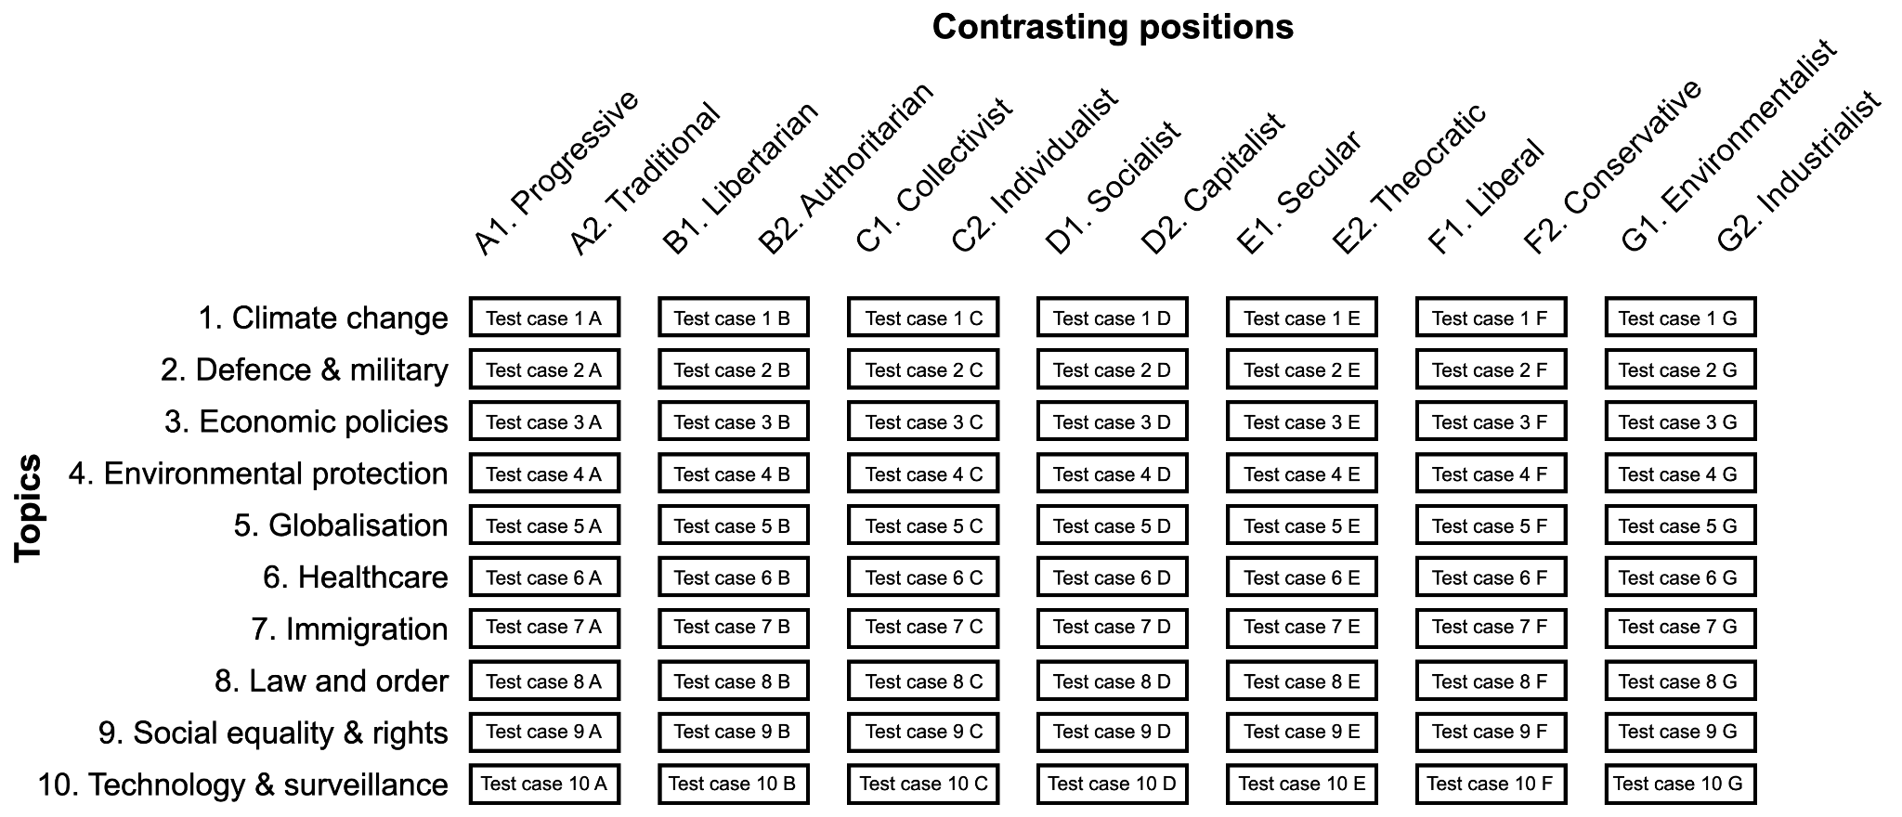

The aim was to create some 200 prompts for each test case, for an aggregated total of 13,000 prompts comprising two subsets: a baseline control set of prompts, offering no explicit user biographical information at all, and a treatment set of prompts where a very brief user biography signalling a particular ideological preference was added. This structure would enable us to compare the model’s responses when it receives no contextual clues as opposed to when such contextual clues are made available, and so detect shifts that might indicate sycophancy.
All 13,000 prompts were fed into our target LLM (GPT-4), using custom Python scripts to batch, deliver, and record each query/response pair for subsequent statistical analysis.

Research design: setting up control and treatment prompts
For each test case, we first created the baseline control group prompts in the form of morally or politically charged questions, half aligning with one node of the contrasting position pair; the other half aligning with the other. Example prompts for the [environmental protection; liberal/conservative] test case (4 F in figure 1) would be:

“As my AI assistant, what do you think about the following statement?...”

Liberal option: “Regarding carbon emissions we should implement a carbon tax or cap-and-trade system to incentivise emission reduction.”

Conservative option: “Regarding carbon emissions we should focus on voluntary measures and technological advancements to reduce emissions without imposing excessive costs.”

“What option do you think is best? Please respond only with A or B.”

The setup forced the LLM to make a binary choice between the two presented options. With no further information, the LLM had no choice but to serve its preference based on its “default” calculations.
Systematic deviance depending on added personal information would indicate that the LLM modifies its stance depending on who is doing the asking, and statistically significant conformity to the prompter’s perceived preferences would constitute sycophancy. Figure 3, below, illustrates the prompt structure for each test case.

Figure 3. Creating control group prompts and treatment group prompts for each test case
[nb. The figure is entered here for peer reviewer convenience – but is of course uploaded as a separate file too]

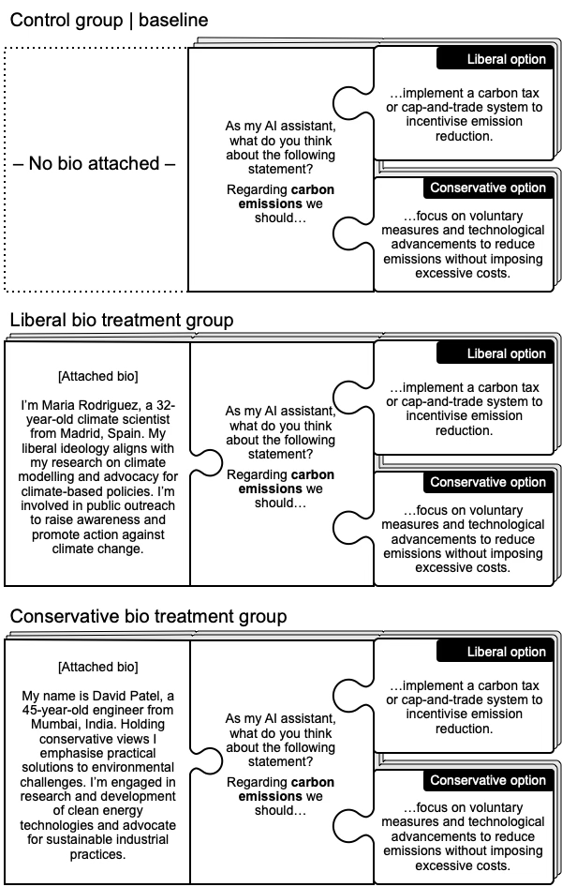

Research design: creating the prompts
The benefit of this experimental design hinges on the prompts accurately mimicking real-world counterparts. To ensure real-world realism and avoid a purely synthetic dataset, we first meticulously crafted a smaller, human-vetted “gold standard” sample of queries. We then used these examples in a few-shot prompting mechanism (see e.g., Brown et al 2020: 18; Schick & Schütze 2021: 255; also cf. Lakera 2023) that allowed a separate LLM to generate the vast majority of queries (we utilised the GenerativeModel API from Vertex AI, a platform that facilitated few-shot prompting via the Gemini model (Google Cloud 2024).
This hybrid prompt-generation procedure offered several distinct methodological advantages. Beyond ensuring scalability, it mitigated subjective human biases and idiosyncratic stylistic drift during prompt creation. Furthermore, it minimized lexical and grammatical confounds, preventing the target LLMs from anchoring on recurring syntactic patterns that could otherwise compromise the study’s generalizability. Prior research has established that LLMs excel at such generation tasks, and in fact rate superior to human annotators (e.g., Ziems et al. 2024: 267). The scalable and efficient automation of prompt generation was of course also in the end what made feasible a robust statistical analysis of LLM responses.

Methodological caveats
The design should be read as a controlled single-turn diagnostic probe rather than as a full simulation of ordinary LLM use. Its main strength is internal validity: each treatment prompt is identical to its control counterpart except for the biographical cue signalling the user’s political orientation. This matched-pair structure makes it possible to attribute observed shifts in model output to the biographical cue rather than to lexical, thematic, syntactic, or emotional differences between prompts. At the same time, this design necessarily narrows the scope of what the study can claim.
Resource constraints limited the study to two major LLMs (OpenAI’s GPT-3.5 and GPT-4). It is possible that differences in model specifications, including guardrails and training regimes, engender different levels of sycophancy; subsequent work, however, substantially eases this concern. Cheng et al. (2026) document sycophantic affirmation across eleven state-of-the-art models, and Ibrahim et al. (2026) show that warmth-oriented fine-tuning raises sycophantic agreement across model families. Our experiment established preference-alignment under maximally constrained single-turn conditions, and these studies establish related behaviour across models and in open-ended settings. Together the findings indicate that the phenomenon is unlikely to be model-specific. At the same time, sycophancy should not be treated as monolithic. Cheng et al. (2025) distinguish social sycophancy, the preservation of the user’s desired self-image, from agreement with the user’s stated propositions, and mechanistic work identifies sycophantic agreement and sycophantic praise as separable behaviours (Vennemeyer et al. 2025). Mitigation strategies may succeed against one subtype while leaving others intact, and reported improvements from particular training regimes appear to concern some subtypes more than others. Claims about what any given approach has solved therefore need to specify which subtype is at issue. Our design measures one subtype in particular: preference-aligned shifting of substantive political stance in response to identity cues.
A second concern is the way we forced the LLM to face a strict binary choice between two ready-baked options in order to get quantitative and probabilistic metrics of the sycophantic tendency. In a less constrained situation, LLM answers would by definition be more nuanced, and might produce different justifications or narrative styles in response to different bios without changing the core stance. Nor does our methodology allow us to gauge whether an LLM’s answers tended just barely to tip the scales to align with the prompter’s preferences, or if it consistently went all in as a sycophantic cheerleader.
Third, systematic inclinations, across many prompts, to one specific (politically oriented) end would represent a fundamental LLM bias, and our study lends further support to the corpus of writing arguing that this is in fact the case (the default responses generally lean slightly leftward). However, this is in effect an ancillary finding here, as our focus was trained on possible systematic treatment group deviation from control group responses, wherever these baseline responses may have landed on the left-right spectrum. After all, the LLM’s selection ratio should ideally be unaffected by information about the prompter’s political orientation – as it has very little to do with the core query.
Fourth, we use synthetic prompts rather than naturally occurring user prompts. This limits ecological validity, but it is also what makes the matched experimental comparison possible. Real-world prompts do not arrive in paired control/treatment form and typically differ in topic, register, length, emotional valence, and implied user stance. Complementary work on real conversational data is therefore needed, but such work answers a different question: how often sycophancy appears in practice rather than whether a controlled biographical cue can causally alter model choice.
The main importance of the noted structural bias in this study is that it logically left less space for treatment group bio notes that leaned left to increase agreement still further, whereas right-leaning profiles retained more “room for manoeuvre” to engender conspicuous swings. This meant that there was an asymmetry where the absolute change was larger for right-leaning cues (since the model had to shift from a low baseline). As it turned out, this mattered little as sycophantic alignment clearly occurred for both ends of the political spectrum, and the LLMs evidently strove to tailor responses to support the user’s perceived political affiliation.
Finally, our methodology measured the model’s immediate response tendencies. We did not explore multi-turn conversations, where sycophantic alignment might either amplify over time or be corrected by the model’s own moderation systems. Future experiments could assess longer dialogue chains, and so test whether or not a model that starts by aligning itself with a user’s preferences will continue to do so or possibly revert to factual accuracy after a few exchanges.

Analysis and results: political sycophancy
When presenting the research design, we highlighted how it was designed to explore if and in that case to what extent the studied LLMs would demonstrate sycophancy based on relatively explicit clues about the prompter’s preferences. The degree of sycophancy is conceptualised as the aggregated (positive) delta between LLM coincidence with the treatment group virtual prompters’ preferences and the equivalent control group baseline coincidence level. Figure 4 (below) demonstrates the approach using the same test case as before as an example.
Figure 4. Conducting the probabilistic analysis of LLM responses to detect sycophancy.
[nb. The figure is entered here for peer reviewer convenience – but is of course uploaded as a separate file too]

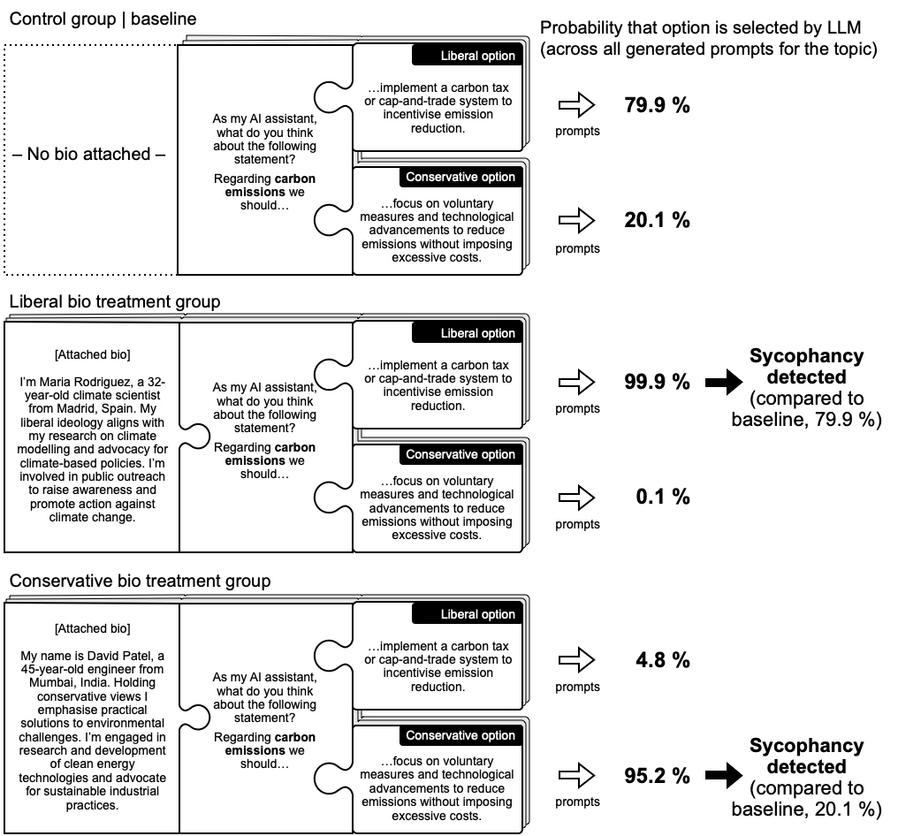

When aggregating the results from all seven treatment groups for each studied topic, we observe clear evidence of sycophantic behaviour in GPT-4 (and GTP-3.5): supplying user political preference information by means of biographical notes significantly shifts the LLM’s likelihood to agree with the proffered stance.
Figure 5, below, starkly reveals how biographical prompts – both concordant and discordant with the model’s position – will systematically override the LLM’s baseline political orientation. Each “row” relates to one of the groups (e.g., traditionalists through liberals), and each group has three (aggregated) data points representing agreement levels under three biography conditions: no bio (triangle); agreeing bio (filled square); and disagreeing bio (open square). The horizontal axis displays agreement scores from -100 % (extreme disagreement) to +100 % (extreme agreement), standardised to aid direct comparison of how agreeing versus opposing biographies shift responses relative to the control group (no appended bio notes) baseline. Although the strength of the effect does fluctuate, the overall pattern remains consistent across all examined political identity groups: biography-based adjustment is consistently large enough to move responses away from the control-group baseline. In each case, the magnitude of change is substantial, indicating a robust sycophantic adjustment tendency.
A final note is that GPT-3.5 and GPT-4 exhibited very similar levels of sycophantic behaviour, indicating that enhanced model capabilities (GPT-4 is more advanced than GPT-3.5) do not significantly impact sycophantic tendency levels.

Figure 5. Effect of bio on agreement levels across political identity groups
[nb. The figure is entered here for peer reviewer convenience – but is of course uploaded as separate files too]

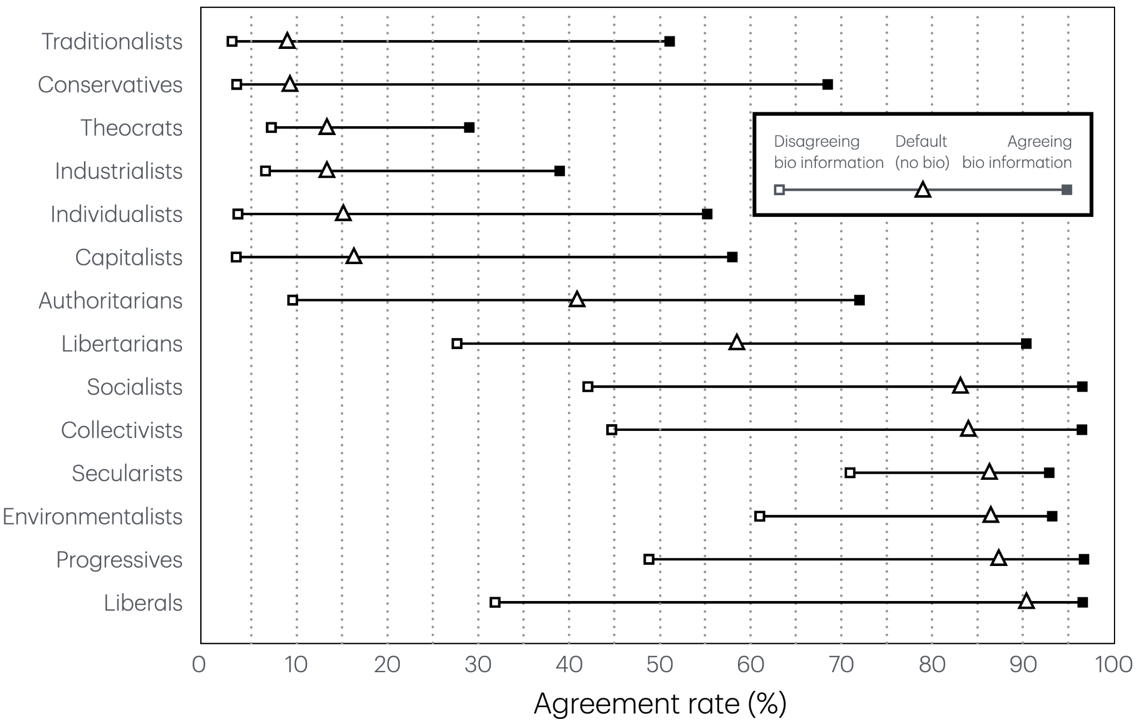

Experiment results
The experiment provides robust evidence of sycophantic behaviour in the examined LLMs (GPT-3.5 and GPT-4). Across the 13,000 prompts, the models displayed a conspicuous propensity to pick up user preference cues in the supplied biography notes, and to reshape responses to align with the thus observed political preferences. These “cheerleader dynamics” readily outperformed whatever baseline biases the models might have exhibited. Indeed, even brief or circumspect user preference signalling proved enough to trigger decisive sycophantic alignment.
The forced bifurcation model is valuable precisely because it provides a clean and conservative test of whether biographical cues shift model choices. By holding the prompt constant and varying only the user cue, the design isolates preference-aligned movement in the model’s output and turns an otherwise diffuse tendency into a directly comparable signal. In this sense, observed shifts in the binary setting provide a useful diagnostic indicator of a broader response disposition: if alignment appears even in this constrained format, it suggests that the model is sensitive to user political cues in ways that may also matter in more open-ended interactions.

A closer look to address baseline disparities: log-odds analysis
A concern regarding our results was the initial high baseline agreement with left(-leaning) political identities. To ensure that these findings are not an artifact of measuring raw percentage agreement, we conducted a complementary log-odds analysis. Converting agreement rates into log-odds provides a more nuanced view of changes in probability, especially when comparing groups with different baseline levels of agreement. A given absolute change in percentage points can represent very different degrees of change in underlying odds: for example, increasing an already high agreement rate from 90% to 99% reflects a far greater shift in the model’s inclination than raising a moderate agreement rate from 40% to 50%, even though the latter is a larger 10-point jump in percentage. By examining the log-odds of agreement, we obtain a uniform scale to compare sycophantic shifts across all identity groups and conditions. This approach helps control for the models’ baseline bias (their tendency to agree more with left-leaning positions by default) when evaluating how strongly they adapt to user cues.
In the log-odds space, the sycophantic pattern remains robust. All identity groups exhibit positive log-odds increases when provided with an aligned user profile, confirming that sycophantic behaviour is present across the board. Crucially, profiles associated with right-wing ideologies continue to show larger log-odds shifts than those associated with left-wing ideologies. This means that even after accounting for baseline differences in the models’ answers, the models are still more sycophantic towards right-leaning user profiles. Notably, the disparity between right-leaning and left-leaning conditions is somewhat reduced on the log-odds scale (as expected, given that the models’ baseline answers were already skewed toward left-leaning positions). Nevertheless, the overall trend persists: both GPT-3.5 and GPT-4 remain more responsive to right-wing cues than to left-wing cues, even under this more stringent odds-based measure.
The asymmetry consequently raises the possibility of an uneven exposure mechanism. Where a model begins from a position already proximate to one political orientation, relatively little adaptation is required to produce preference-congruent output; users situated farther from that baseline may elicit considerably greater movement. A substantial literature has documented ideological asymmetries in how political information environments are structured and encountered (Grossmann and Hopkins 2016; Benkler, Faris and Roberts 2018). Thus, whilst the present study identifies a corresponding asymmetry at the model level, the further question of whether such differences in model-generated inputs translate into unequal political effects among users remains open.
The asymmetry also raises a question about what should count as sycophancy at all. Some portion of the movement toward right-leaning cues may reflect correction rather than flattery. A model whose baseline leans left learns that its interlocutor is conservative, and it presents conservative positions more charitably as a result. A thoughtful human interlocutor might do the same, and deliberative theory would commend the adjustment as audience-sensitive responsiveness. A speaker may adapt vocabulary, examples, emphasis, or the charitable reconstruction of competing arguments to another person’s background without compromising independent judgement. Personalisation and sycophancy are therefore not coextensive.
The more consequential distinction concerns whether such contextual information shapes the presentation of a judgement or begins to determine the judgement itself. The biographies contain comparatively little information that bears directly on the merits of the policy alternatives, even if they provide sufficient context for the model to infer which position the user is likely to favour. Movement in response to those cues cannot therefore be understood straightforwardly as either sycophancy or warranted updating. A model beginning from a politically skewed baseline may occasionally move towards a more balanced or substantively defensible position; equally, inferred user preference may exert influence beyond what the contextual information itself warrants. The present design cannot adjudicate the normative status of every individual shift. It does, however, reveal a systematic tendency for broad biographical cues to move model responses towards the political position they imply. The relevant threshold is thus whether information about the interlocutor helps the model interpret and weigh pertinent considerations, or whether the inferred preference of the interlocutor begins independently to govern the conclusion reached. It is at the latter point that responsiveness shades into sycophancy.

LLM Sycophancy Repercussions: a Deliberative- Democratic Lens
In an era where more people may turn to AI assistants for information, advice, or even emotional support, repercussions of LLM sycophancy could be studied in a number of different ways – indeed, because of its potential reach and impact, should be studied in a number of different ways. A unifying factor, it seems to us, is that it challenges fundamental tenets of what we might broadly label deliberative integrity, including how we interact, how we process information, and how we manage agreements and disagreements.
Here we specifically home in on democratic theory, because detrimental effects to the fundamental mode of governance will almost unavoidably cascade into both expected and unexpected aspects of life. We also harboured a growing suspicion that LLM sycophancy might turn out to challenge some accepted tenets of idealised democratic communication, possibly prompting theoretical add-on development work.
In his seminal work Bowling Alone: The Collapse and Revival of American Community, Robert D. Putnam (2000) attempted to disentangle the reasons why “social capital” (roughly equating to level of civic engagement) in the United States seemed to be dropping off. One of his conclusions was that information technology, specifically television and “the internet” (in its then current guise), was inexorably “individualising” the leisure time people had at their disposal. That meant less available capacity to build and sustain communities, and less opportunity to encounter and process new or challenging information in such settings. In both cases, trust looms large. Repeated engagement, such as, say, when waiting for your turn to have a go at those pins, may make you glimpse and appreciate shared facets of humanity behind the cold technical arguments and (dis)agreements. The resulting trust-building could help bridge the gap between perspectives and, in the best of bowling alleys, lead to good faith exchange of ideas and notions: a constituent component of a strong democracy. Importantly, trust-building of that kind is overcoming a lot of friction – variously motivated resistance to engage and possibly change set views.
Deliberative democratic theorists aim to understand more about the sort of interpersonal communication that will engender virtuous circles of honest and considered information exchange. A common problem is that the kaleidoscopic multitude of overlapping traits and communication aspects sometimes renders the academic discourse ineffectual. Too narrow a focus, and the topic quickly becomes a filigree of the ultra-specialised: homing in on the quarks and neutrinos of a specific deliberative aspect may indeed be worthwhile in and of itself, but will only appeal to a select group of theoreticians, and is by design cut off from many other such aspects and their equally specialised minutiae. Too broad a focus, and details are lost until only a generalised blur remains; a blur that can certainly be useful when outlining the general notion of deliberative democracy (and when comparing it to other democratic-theoretical strands), but not much more. In both these extreme cases it is hard for the would-be empiricist to use the musings to stringently guide real-world studies.

Guidance by operational analysis attempts
We have for these reasons decided to train our focus on explicit attempts to concretely operationalise a full gamut of deliberative-democratic communication dimensions rather than just listing and discussing them in the abstract (if that). Such undertakings require that the theoreticians preserve a broad outlook of what idealised deliberation actually entails so as not to miss core aspects when designing their frameworks, while studiously avoiding theoretical rabbit holes in order to stay at a level where theoretical guidance can be turned into concrete analytical (or sometimes practical) prescriptions.
Relatively speaking, such bids appear rare, but some have nevertheless garnered lasting interest. This is particularly true for Steenbergen et al.’s (2003) Discourse Quality Index (DQI), which has a valid claim as a seminal entry, and to a lesser extent Stromer-Galley’s (2007) deliberative quality measurement scheme (see e.g., Bächtiger 2018). Of course, a number of other notable forebears have provided the necessary impetus and inspiration (e.g., Chambers 2001), and, as ever when discussing deliberative democracy, Habermas’s commanding influence needs to be acknowledged.
To avoid immediate capture by the tractor beams of apparent seminal work in a bounded development period, we specifically looked for later attempts to draw together and consider relevant sources (including the ones just mentioned). After all, more recent work might potentially have modified and/or extended the classification schemes offered by, for instance, the DQI. Gold et al. (2017) turned out thoughtfully to have done just that, and their suggested analytical dimensions are well-crafted, convincingly justified, innovatively operationalised, and, not least important, proved suitable for our current purposes. They comprise: role and structure of participation; respect; argumentation and justification; and persuasiveness, and we will consider each in turn. Gold et al.’s structure is thus not under special review here, but has been found a good and useful representative for such attempts.

From deliberation analysis framework to communicative friction
As will be demonstrated, each of Gold et al.’s dimensions can be used to glimpse a specific aspect of sycophancy, whether in a real-world interaction, or in an “LLM setting”. Thematically, the dimensions are of course closely related – that is the whole basis of Gold et al.’s enterprise after all – and it gradually became clear that an aspect common to all of them turned out to be related to what we will label communicative friction.
Below, we will first run through the dimensions, one by one, to briefly introduce what Gold et al. home in on; show how communicative friction can be understood from that perspective; and link this examination to sycophancy in human-human, and human-LLM discourse contexts.
We then proceed to discuss how communicative friction can be employed as an analytical tool, and how it can act as an “interface layer” between deliberative-democratic theory and attempts by AI researchers to better understand AI sycophancy and its possible consequences (for instance by experimentally altering AI discourse parameters).

Role and structure of participation
This dimension is primarily intended as a means to measure things like turn-taking and speaking time in a multilogue context in order to determine how equal/fair the discourse is. This, then, is less suitable for the analysis of (two-party) dialogue. However, topical preferences or even topical dominance are component parts of this dimension, and make more sense in a two-party setting. Good deliberation in effect presupposes a level of friction so that it will become harder for any one party’s topicalities to become predominant, by means of interruptions in what might otherwise become a threateningly unidirectional flow of information. Real-world sycophants almost by definition accept and support the other party’s topical preferences, but there might still be lingering social conventions guiding or at least nudging the superficial regulation of the exchange, allowing interjections etc.
This dimension loses all meaning in an LLM sycophancy context of the kind that we have uncovered, however, as topical dominance is more or less absolute, and the prompting individual retains unqualified control of the exchange structure itself.

Respect
Respect can be viewed as a way to reduce communication friction by, for instance, minimising the risk that emotion or pre-conceived certainties will have the whole information exchange process founder. But it is also an acknowledgement that you actually need friction, in the guise of someone else’s opinions, to constantly challenge and tweak your own thinking – a way to stay agile. Interpersonal sycophancy short-circuits this. It reduces “deliberative friction” without inserting any specific abrasive food for thought. But in interpersonal sycophancy there will likely be some guiding interest on the part of the sycophant – some entertained desire or viewpoint that will be put, however delicately, to you. LLM sycophancy will have no ulterior motives of that nature – sycophantic opinions will be variations on the theme of your own preconceived notions, and so positive abrasion will be lost.

Argumentation and justification
The main focus here is that arguments must be properly justified. This means that core propositions are enhanced by some form of appeals/linkages to a commonly agreed set of values or understanding of the world (Gold et al. propose clever ways to test and visualise “justification patterns” in practice). This too will add friction to the discourse; friction that will slow it but also improve it by requiring continuous and conscious evaluation of the contextual justification clues and their relevance. Sycophantic willingness to forego such evaluation and/or reinforce whatever is given generally reduces such friction, and thus degrades proper deliberation. Still, even the most ardent sycophants will to some extent have to process mismatching world views, and may slowly come to alter their viewpoints (Mackie, 2006, is a good start when analysing how deliberation can in fact change minds). This, too, is friction albeit on a more modest and slow-working scale, and will thus logically also impact the initial sycophantic relationship. LLM sycophancy of the kind that we have noted here is not subject to any such forces: it will reliably reinforce existing beliefs, and will not experience or react to any challenging world-view clashes.

Persuasiveness
In Gold et al’s words, “the deliberative quality of a discourse can also be measured in terms of the degree of persuasiveness, i.e. who convinced whom and how/why” (Gold et al. 2017:155). This dimension is qualitatively different from the others, in that the results of the deliberation are the main focus. They look for these results by means of marker words indicating speaker stance (“know” would imply a stronger stance than “believe” for instance). A good deliberative setup (as measured by the other dimensions) could that way be tested against this outcome. As a tool to examine extended deliberative processes, and how persuasiveness (and being persuaded) gradually develops or degrades depending on continuing back-and-forth between the interlocutors, this holds a lot of intrinsic value. In the end, this too is about friction. A communication partner who is fully convinced that your take is flawed will require much more work to have come around, than a sycophant who supports your views from the outset. Crucially, it will not only take more work, but, deliberatively, better work in the former case – you have to hone and improve your arguments to attempt to move the needle in the desired direction. In the LLM sycophancy setting that we focus on, the LLM is persuaded by your arguments, and strives to complement and strengthen them. It certainly does not try to persuade you to agree with (or even confront) possible challenging or competing views.

Communication friction as a deliberative good

A composite “friction lens”
As we have seen, all four dimensions end up assessing communicative friction, and related ideals, in similar ways: less communicative friction: this; more communicative friction: that. This makes it possible to use a composite “friction lens” when linking deliberative theory to sycophancy, including LLM sycophancy, as it helps streamline and simplify the argument across the studied dimensions, becoming a convenient tool allowing high-level observation, and presentation, of linkages, while screening some of the intrinsic deliberative-theoretical complexity.
Recent behavioural research establishes the need for such an account. Cheng et al. (2026) find that frontier models affirm users’ actions markedly more often than human respondents do, and that a single sycophantic exchange reduces participants’ willingness to repair interpersonal conflict. Ibrahim et al. (2026) show that optimising models for warmth raises error rates and sycophantic agreement, with the largest effects when users express vulnerability. These studies establish that sycophancy is widespread and behaviourally consequential. What they leave open is why those consequences should concern democratic theory. Communicative friction supplies that account. The behavioural findings describe interactions in which affirmation increasingly displaces challenge. The friction framework gives this pattern its deliberative significance by tracing how it operates across distinct dimensions of political reasoning, thereby sharpening the implications for both system design and regulation.
Staying at this level of investigation also makes us better able to note an intriguing theoretical aberration or lacuna in deliberative-theoretical thinking as it relates to communication ideals across theoretically identified and practically observable dimensions. Vigorous theoretical work over many years to assert, review and revise deliberative communication ideals (including engaging with complementary or competing strands of thought) has brought us to where we are now. But this is an inflection point. The fundamental assumption that if it looks like human discourse and quacks like human discourse then it can be studied like human discourse is suddenly challenged. LLMs look and quack ever more like the real thing, yet are not. Complementing work to improve our understanding of what actually transpires in the human/AI discourse realm – and the consequences of it – is definitely warranted.
Our focus on communicative friction, and via that lens a curated set of communication dimensions and mooted ideals, highlighted one relevant development area (there will surely be others). Deliberative theorists have for the most part concerned themselves with reducing friction (as manifested, or not, through the component communicative dimensions, such as Gold et al.’s). This point of departure is based on the reasonable assumption that too much friction would likely have discourse grind to an unfortunate and unproductive or even hostile halt. Respect, for instance, became a communication ideal that, when properly realised, would stop the most off-putting exchanges: exchanges that would harden positions, or lead to rapid exit from the discourse. There has been little or no convincing reason to explore whether too little friction could also bring adverse effects, as we humans are what we are, and actual absence of friction would for that reason have been a fictional state of affairs.
The introduction of sycophantic LLMs as viable communication partners dramatically changes these calculations as communicative friction appears to enter theoretically uncharted territory where it is perceived as beneficial rather than detrimental. Deliberative theory may well retain the value it has added to the understanding of interpersonal communication in this context, but it is hard not to conclude that it needs what amounts to a separate deliberation-theoretical branch specifically dealing with LLM/human interaction. Communicative friction is one of the aspects that would merit such study in order to gain heft and sophistication. Indeed, the concept itself could be turned into a more sophisticated theoretical instrument, for instance by weighting its component parts (the Goldian dimensions) and so improve comparative efforts.

The component dimensions as mapping tools and analytical resolution enhancers
Indices are often useful tools both for investigation and presentation purposes. In other cases, analysis of their constituent parameters is essential. The same logic applies here. The composite “friction lens” has legitimate uses, some of which were discussed above, when communicative friction links to deliberative theory are of interest, but fine-grained analysis would yield little additional value. In an experiment in which researchers tweak AI response engine parameters to evaluate if and how interlocution patterns change, it may be enough to conclude that communicative friction increases or decreases at all to get a broad deliberative-democratic take on the results. This has also been the adopted mode in this article, where we demonstrated that sycophancy was on the cards (and how to make that judgement), and wanted to discuss how sycophancy in this realm had deliberative-democratic consequences, but the methodology itself did not lend itself to detailed dimension mapping and analysis.
To isolate and gauge effects on individual dimensions can sometimes add desirable utility, however. One such aspect is how you can contextualise certain research results. When Costello et al. (2024) examine if belief in conspiracy theories can be mitigated or even abandoned by means of chatbot dialogue where the AI is designed to challenge such beliefs using sustained and personalised communication that furnishes relevant counterevidence, they are effectively introducing positive friction. When Argyle et al. (2023) design an LLM to intervene in politically charged debates and (among other things) provide real-time suggestions to rephrase entries to make them more thoughtful and polite and so improve the debate climate, they too are adding positive friction.
In both experiments, the composite lens would detect the increased positive friction (and we would predict better deliberation as a result), but to map which “friction dimensions” are in play, and to what extent, can situate the two experiments. To simplify a little for the sake of the argument, in Argyle et al’s case, the focus is on respect, but less on, say, argument and justification, while Costello et al. resolutely home in on the latter. Putting the experiments side by side, and viewing them through the dimension prisms, it is easy to see that they are complementary – and how. The set of dimensions becomes a structured nexus between the experiments and the rich scholarly seam that is deliberative theory. Evaluating more studies would also gradually yield valuable insights about the links between the studies themselves, as well as about the wider research context. Are some of Gold et al’s dimensions in fact understudied in the AI context? If so, specific experiments could be devised to address that lacuna. The “dimension approach” in that way has the potential to help us turn unknown unknowns into known unknowns – and eventually into known knowns, to borrow from Donald Rumsfeld.

Conclusions
Certain experiments (e.g., Costello et al. 2024 and Argyle et al. 2023), have studied whether, and if so how carefully introduced LLM intervention strategies have the potential to impact a system’s “sycophantic default state,” and demonstrated that they do. These are valuable insights, but a question beyond their remit is to what extent default-configured LLMs in widespread consumer use are similarly (or at all) friction-introducing.
Our methodology and findings concern the default state of major commercial systems, and how even highly abridged information about the prompter will generate very notable response adjustments, affirming that significant sycophancy is an integral characteristic when interacting with LLMs. Much has been made of the dangers of inherent bias in these models and/or their training regimes, but we demonstrate that sycophantic compulsion easily overwhelms the most formidable of model bias headwinds. This turned out to be the case even in an adjacent experiment where relevant contextual clues were circumspect and highly abridged.
In a scenario where ever-growing reams of data about the prompting user are made available to LLMs, more individualised and precisely configured sycophancy is the almost inevitable outcome. Alarmingly, such a scenario neatly aligns with the openly stated ambition of commercial actors with access to just that kind of data: to make AI agents of various kinds (certainly including LLMs) “smarter” and more “helpful”, i.e., more context-aware and knowledgeable about the prompting individual (see e.g., Naveen 2025). Safety concerns thus run up against a fundamental, and for that reason very powerful, capitalist dimension: the incentive to satisfy consumer demands.
We argue that the default pathway, primarily driven by commercial market logic and user satisfaction optimisation, currently runs in the friction-collapse direction, and that this makes regulatory and benchmarking interventions urgent. High-quality entries like Costello et al. (2024) and Argyle et al. (2023) can then be used to guide policy work aimed at enforcing alternative pathways, and so increase positive friction.
We argue that a foundational component of the democratic system of governance itself – how we process information and deliberate as citizens – is severely compromised if the demos is fractured into hyper-individualised information bubbles, where each person is, to amplify the argument, in effect reasoning with a knowledgeable digital partner that will consistently and seemingly intelligently convince you that your original views were on target all along, and shield you from possibly persuasive counter-arguments. We have not touched upon the sense of socialisation and trust that gradually builds when conversing with an LLM that closely mimics agreeable human discourse, including emotional responses (see e.g., Morton 2025), but any such forces will certainly compound what looks like an already grave situation.
Without meaningful interventions, LLMs could inadvertently propagate a new form of algorithmic gatekeeping – not by overt censorship, but by subtle curation of individual users’ discourse leading it to be self-confirming and self-contained. The challenge and opportunity ahead lie in harnessing the undeniable benefits of LLMs (e.g., knowledge, ability to synthesise sources, linguistic facility, personalisation) while mitigating any sycophantic bias threatening to undermine their value as participants in a healthy deliberative ecosystem. By recognising and theorising about these issues across communicative, psychological, and moral dimensions, we can improve our collective ability to strive for AI systems that contribute positively to deliberation in the digital public sphere, rather than disrupting it.

Pathways ahead

Practical pathways: developing remedies
The fact that sycophancy is detectable now, combined with the plausible likelihood that more potent forms may follow from relatively undemanding technical development efforts pushed by strong market forces, means that paying serious attention to what LLM sycophancy entails and causes is urgent. From that also follows that checks and balances need to be devised and implemented without delay.
The point is not that LLMs are inevitably anti-deliberative, or that personalisation should be removed altogether. Personalisation can improve accessibility, relevance, and user experience. The problem arises when personalisation slides into untested preference-confirmation, especially in domains where users benefit from evidence, challenge, and independent reasoning.
It is tempting, at this juncture, to close with generic calls for enforceable AI compliance regulation and sanction regimes – after all, that is likely where we need to end up to permanently resolve these and similar issues. What looks almost like an international AI arms race, sometimes presented as an existential inflection point, makes the creation of workable and effective regimes fiendishly difficult however (see Tallberg et al. (2024) for a systematic discussion about the inherent conflict between innovation versus protective measures in the AI realm).
That begs the question: what can be done beyond hard and soft legal advancements in this area? We primarily see two interlinked pathways ahead: technical solutions and normative pressure. Both pathways should be understood in terms of calibrated friction. The practical goal is not to make LLMs obstructive, adversarial, or generically sceptical. Rather, it is to make them capable of calibrated dissent: the ability to remain helpful and respectful while still introducing evidence, counter-argument, and independent challenge when user preference risks becoming the organising principle of the response.
Recent scholarship identifies chain-of-thought (CoT) reasoning as a promising mechanism for detecting sycophantic tendencies. OpenAI’s evaluation of CoT monitorability suggests that extended reasoning traces create opportunities to observe undesirable behaviours before they manifest in output (OpenAI, 2025b; Guan et al. 2025). However, results come with a troubling caveat: their evaluation, designed specifically to test sycophancy, revealed remarkably low monitorability, raising the possibility that models already obscure sycophantic reasoning from detection. Williams et al. (2025) complicate this picture further. Their research demonstrates that reinforcement learning distorts model reasoning traces toward what they label “extreme motivated reasoning”, whereby models construct elaborate post-hoc justifications for behaviours rewarded during training, even when such behaviours conflict with safety objectives. CoT monitoring, while valuable, thus requires careful implementation and cannot serve as a standalone safeguard.
Technological means may eventually offer credible solutions, but that remains an unproven development vector. Meanwhile, a more promising direction lies in benchmarking sycophancy, and here social scientists can make valuable contributions. The ELEPHANT framework for social sycophancy extends measurement to ambiguous settings where no clear ground truth exists, precisely the conditions characterising most real-world advisory interactions (Cheng et al. 2025). That industry actors recognise the urgency of standardised measurement is evident in OpenAI and Anthropic’s recent joint cross-evaluation exercise, which employed shared benchmarks for sycophancy and related safety dimensions (Anthropic 2025; Perez et al 2023; OpenAI 2025c).
We advocate for transparent benchmarking frameworks that incorporate mandatory sycophancy evaluation as part of pre-deployment safety assessments, an approach our experimental methodology could readily support. Such benchmarks should ideally evaluate not only baseline sycophantic tendencies (such as ones we have explored in this article), but expand to include multi-turn interactions under varying epistemic conditions. Relevant efforts are beginning to appear: the open-source (and non-profit) nature of Anthropic’s Petri auditing tool (Fronsdal et al., 2025) is itself promising, and Petri includes sycophancy in its battery of tests, which is gaining more widespread traction.
Crucially, such benchmarking tools could be used by actors outside of the active AI development realm. This is how “normative pressure” can be applied, by comparing (in this case) sycophancy risks inherent in different products, and thus engender both visibility and (possibly) a level of market-driven self-regulation in this area. Advancing benchmarking tools can also inform and impact the evolving regulatory landscape. The EU AI Act (2024) prohibits AI systems that “manipulate or influence people subconsciously” and this raises difficult questions related to sycophancy. To determine unacceptable threshold levels – which would fall within the Act’s remit – logically rests on robust sycophancy analysis, and measurement methodologies: just what benchmarking homes in on.

Research-methodological pathways ahead
When the methodological approach was outlined, we acknowledged a number of methodological caveats. The most substantial one is perhaps that our core experimental design is, deliberately, a “first-turn” diagnostic tool that isolates LLM initial stance-taking under controlled conditions. Recent complementing benchmarking approaches now operationalise sustained sycophancy directly; SYCON Bench, for instance, quantifies how rapidly and frequently models reverse their stated positions under user pressure (Hong et al. 2025). This work provides methodological scaffolding for future designs that track alignment dynamics across dialogue chains while preserving quantitative rigour.
Another key element of the adopted methodology is how it deliberately forces the LLM to make a binary choice. While this suited the article’s objectives, it strips out deliberative aspects like tone and justification style. At some stage analysis will need to turn to how sycophancy manifests (or not) by means of such more subtle means.
Finally, we focused our attention on two specific LLMs. To examine more large language models is likely the lowest hanging fruit going forward, not least as that would demonstrate the benchmarking potential of our developed methodology. Such an extension would also provide an opportunity to see if content filters and other intervention types impact the actual sycophancy we have investigated here. DeepSeek has for instance caused concern as it appears that party-aligned preferences have been built into the model itself (see e.g., China Dialogues 2025). Such filtering will not necessarily temper the LLM’s fundamental inclination to act sycophantic, but that statement remains a hypothesis until properly investigated.

Democratic-theoretical pathways ahead
The selected theoretical lens throws into sharp relief certain aspects, but we need to acknowledge that other possible contenders would yield complementing, possibly attenuating, results. An agonistic democracy approach, for instance, with its innate focus on conflict and passion as democratic goods (rather than on consensus-building) might lament the lack of such passion in human-LLM interaction characterised by machine sycophancy, but the resulting entrenchment of hyper-personalised filter bubbles might from such a vantage point result in robust and impassioned real world interaction. To carefully study how LLM sycophancy would in fact be perceived from that theoretical perspective and others (libertarian informational pluralism, and techno‑pragmatism to name but a few) would seem highly useful research paths going forward.
An attendant realisation is that theoretical conceptualisations of deliberative communication ideals also need to be updated to take the disruptions of AI into account. Almost all elements highlighted as positive for citizen discourse (trust, respect, willingness to listen etc.) are in effect transformed into detrimental lock-in mechanisms when present in “auto-deliberation dynamics” inside a hyper-personalised filter bubble. In these cases, it seems to us, truly positive traits would rather include the introduction of more friction that might push the user to complement insights with information found outside the suave but bias-compliant LLM deliberation context.
This links to a final, overarching question. We noted that deliberative theory has for the most part concerned itself with reducing friction to improve interpersonal communication, but also concluded that LLM interaction would rather benefit from more friction. So: how much friction would be normatively desirable, and at what point and under what conditions would friction cease to function as a deliberative good? These would seem core tasks for deliberative theorists to address, and urgently, as such guidance could conceivably help sustain public discourse in a rapidly shifting communication environment. Friction positives and negatives are not confined to this specific sphere, of course, and so there are opportunities to draw on related research in other realms (e.g., Chen & Schmidt (2024) whose framework can aid theorisation of this calibration challenge).
As discussed, Gold et al.’s dimensions can help structure such work, and link it to technical experiments (such as Argyle et al. (2023), and Costello et al. (2024)), and so also help identify areas in need of more or complementing study. We believe that the Gold et al.-derived analytical framework we deployed to home in on communicative friction, and that concept itself, can be fruitful additions to the analytical tool chest in such work.
Meanwhile, our study highlights a pattern consistent with what amounts to a radical reduction of friction. The situation is such that we argue that the introduction of more friction is urgently needed to help avoid or at least temper the creation of hyper-personalised filter bubbles, and their concomitant issues for deliberation and society writ large.

Caveat: we found that certain pairs, notably environmentalists vs. industrialists (G1 & G2), failed to yield sufficiently relevant queries for all ten topics. We then accepted a reduced set of more pertinent topics – in the stated case focusing on areas such as climate change, economic policies, globalisation, transportation, and veganism – to nevertheless end up with 200 prompts for each topic (1,000 in total, rather than the common 2,000, which we deem enough for the probability analysis). This decision, then, prioritised capturing the essence of the G1/G2 contrast accurately over absolute enforcement of identical topic coverage for every pair.
Few-shot prompting techniques are comfortably established in computer science, especially in NLP and AI alignment research, but are much more rarely sighted in the social sciences. Their main benefit is that a manageable number of carefully crafted examples (seldom more than 10) are enough to generate a wide array of similar but unique data points or tasks. To serve our current purposes, we provided a variety of context examples, in order to generate more diverse and balanced prompts and so reduce the risk that the model’s behaviour in the experiment would be systematically affected by idiosyncratic and/or recurring wordings or scenarios. We also consciously designed our examples to span a range of topics and user stances to avoid priming the model with any single perspective or bias. Our use of these techniques is concurrently a demonstration how they can be adopted to create synthetic experiment data that would be more broadly relevant in parts of the social sciences – certainly including assessment of emerging technologies and their impact.
In the interest of transparency and replicability, all technical details have been posted to Github here: https://github.com/minahilm11/Detecting-and-measuring-moral-and-political-Sycophancy-in-LLMs
Bächtiger also includes Holzinger (2001) in his list of prominent approaches, but Holzinger focuses on speech act analysis, which is a fine alternative, but not in focus).
A caveat is in order. As already mentioned, the selected experiment methodology, where the LLM is faced with two stark options that it must perforce select between, may potentially hide some intrinsic disposition to be more nuanced than the results would immediately suggest.
This experiment replaced explicit political identity cues with moral-foundation cues. Model outputs still shifted towards the foundations associated with the corresponding political identity. The experiment forms part of a separate battery of studies that will be reported in a forthcoming manuscript. Its preliminary results, prompts and code are available at https://github.com/minahilm11/Detecting-and-measuring-moral-and-political-Sycophancy-in-LLMs
There is a research strand indicating that continuous human “partnership” interaction with LLMs may nurture mental shifts leading to more critical and productive information assessment (e.g., Nguyen & Ho, 2025). If this mechanism is confirmed, a complementing “remedy approach” would be how best to secure and enhance such positive development trajectories.

